Module 4 Project

Michael Rothbauer

Rasmussen College

Author Note

This paper is being submitted on December 2nd, 2018, for Michael Rothbauer’s Advanced Mobile Web Applications.

Module 4 Project

Website link: file:///C:/Users/micha/Desktop/School/CIS4655C/CIS4655C-Advanced-Web/Module%204/Project/mod4project.html

Repository: <https://github.com/michaelrothbauer/CIS4655C-Advanced-Web/tree/master/Module%204/Project>

Images:

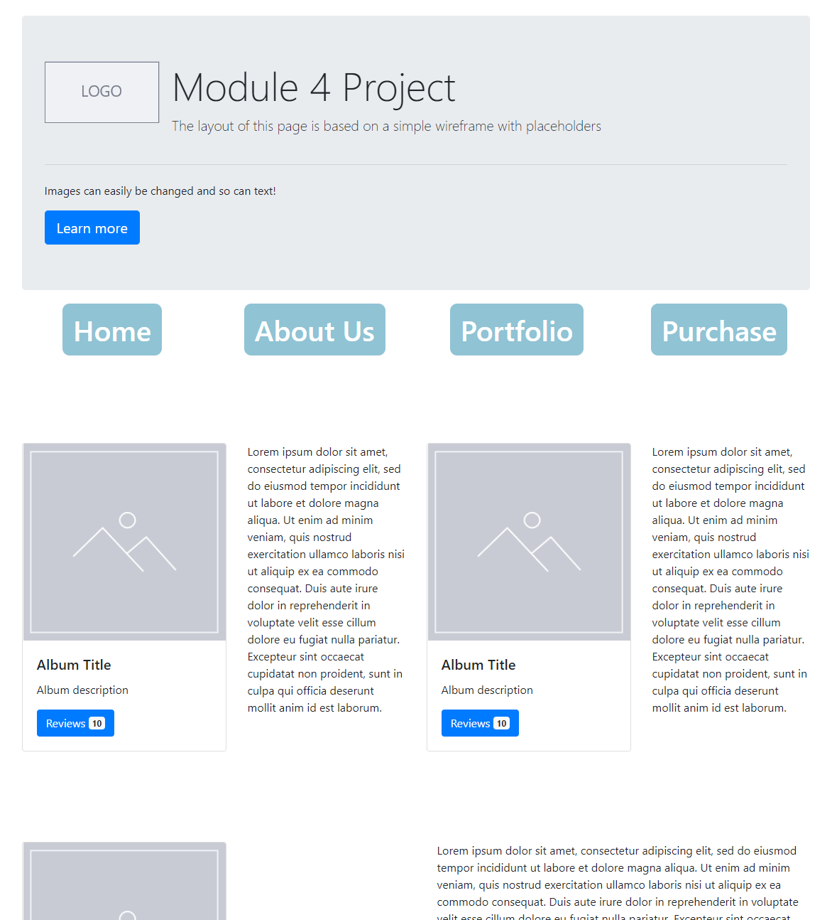

Galaxy S5:

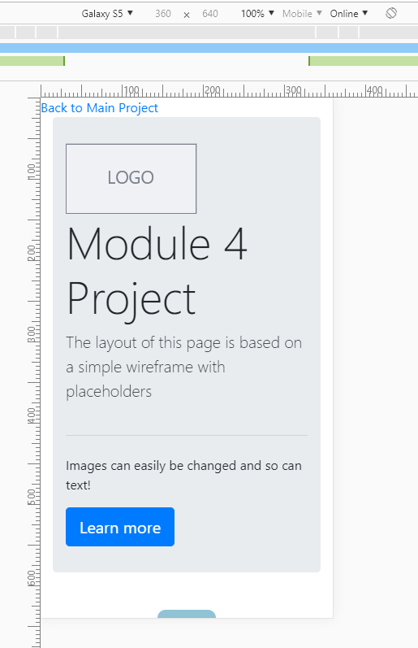

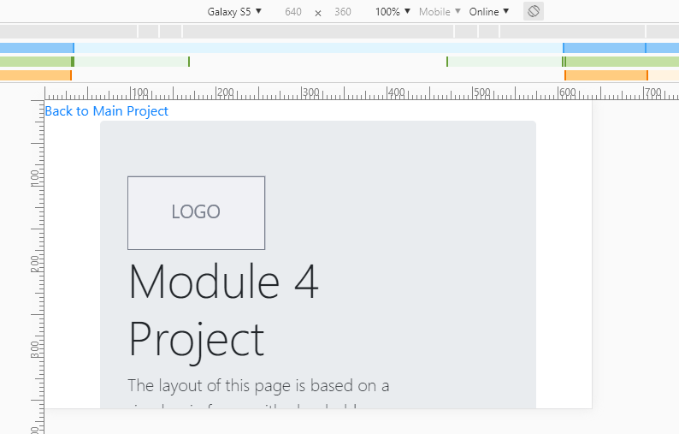

iPad:  
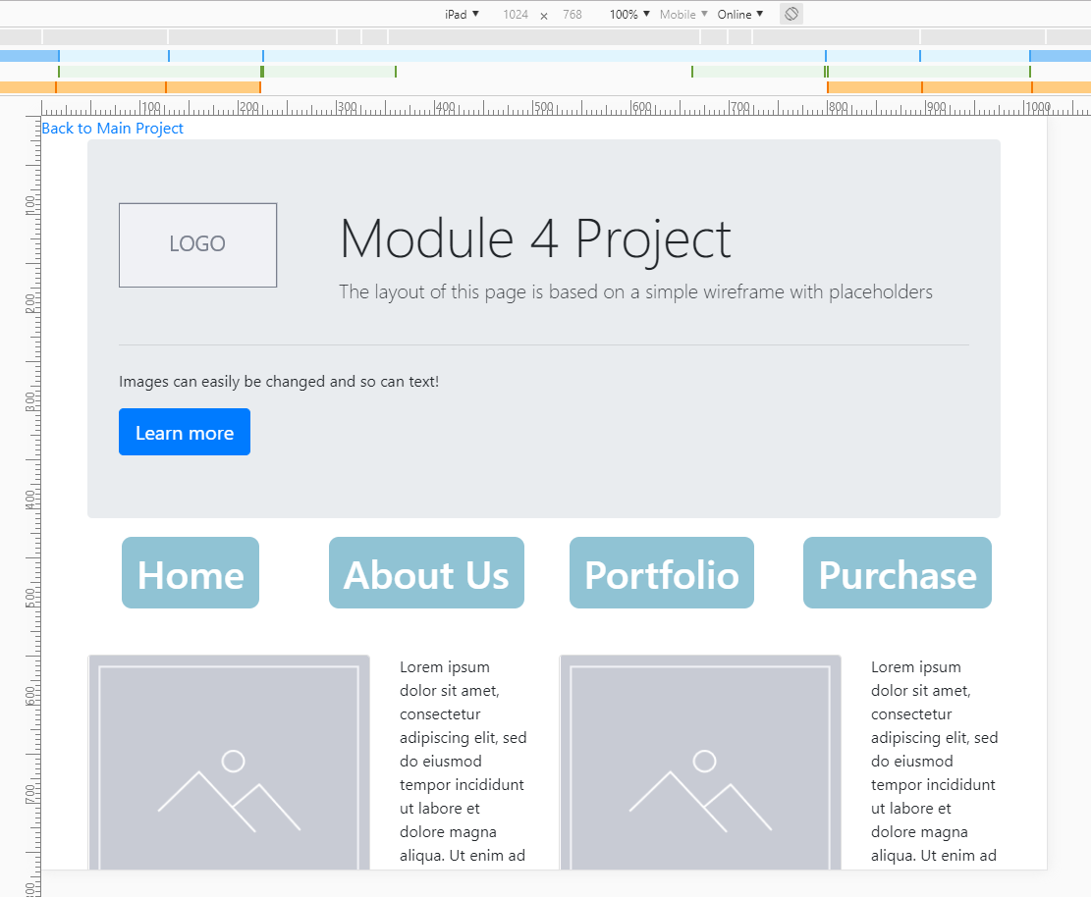

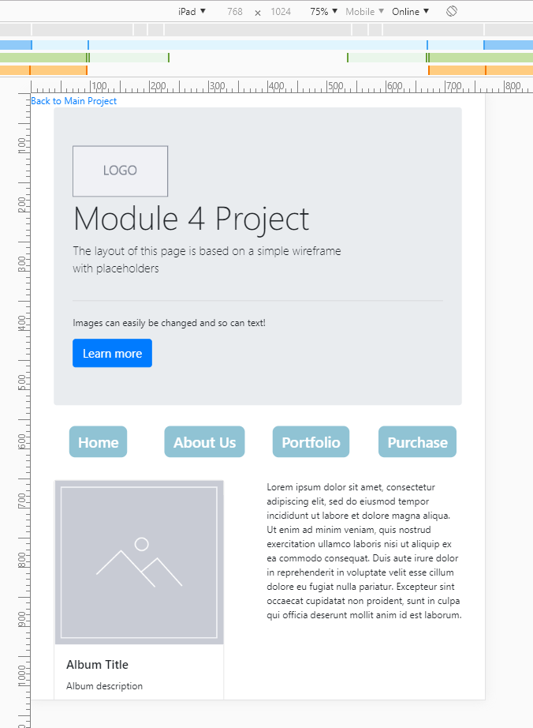 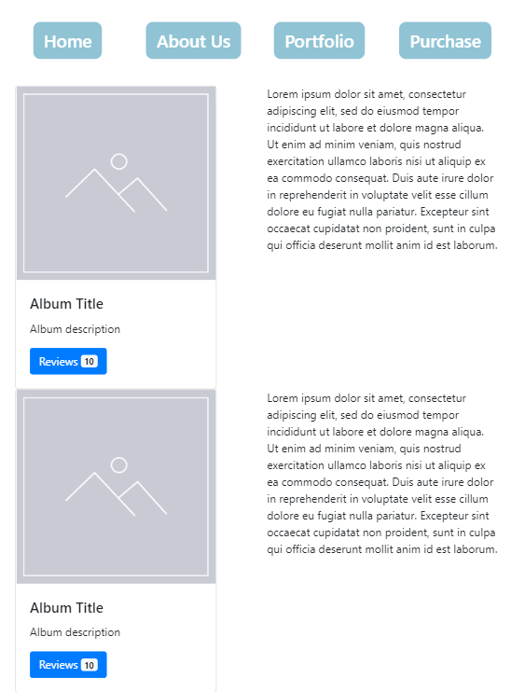

iPhone X:

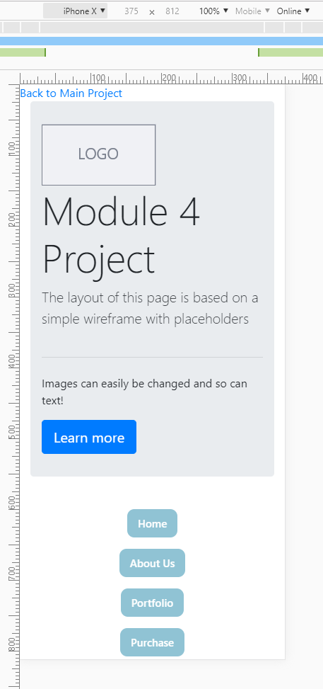

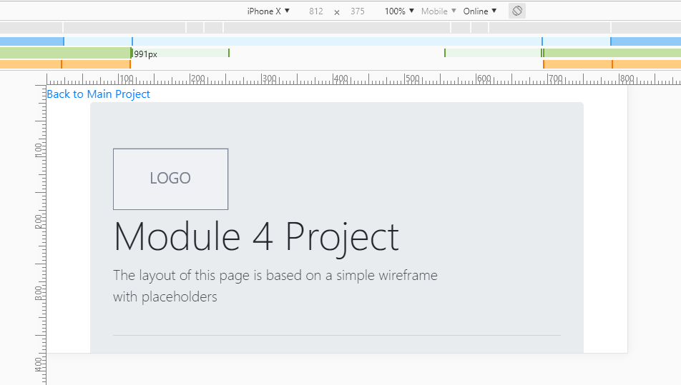

Pixel 2 XL:

